AMERICAN RED CROSS, MIDWAY-KANSAS CHAPTER

SPONSOR ORIENTATION GUIDE
2007-2008

TABLE OF CONTENTS

Section I: INTRODUCTION and CONTACT INFORMATION 2

Section II: STEPS IN SETTING UP YOUR RED CROSS CLUB 3

Section III: PROJECT IDEAS 5
Preparedness Projects 5
Service through the Red Cross Projects 7
Service to the Community Projects 9
Service to Group, School or Student Projects 10
Prevention Projects 12
Service to the World Projects 14

APPENDICES 15-28
Appendix A – Sponsor Information Form 15
Appendix B – Student Member Form 16
Appendix C – Project Activity Form 17
Appendix D – Resources for Service to Community Projects 18
Appendix E – Resources for Service through Red Cross Projects - Holiday Stocking 20
Appendix F – Resources for Service through Red Cross Projects - Bookmarks 21
Appendix G – Resources for Service through Red Cross Projects - FA Kit in a Can 22
Appendix H – Resources for Service through Red Cross Projects - Comfort Kits 23
Appendix I – Resources for Prevention Projects 24
Appendix J – Resources for Service to the World Projects 26
Appendix L – Midway-Kansas Chapter Programs & Services 27
Educational Resources See American Red Cross School Catalog

American Red Cross Mission
The American Red Cross, a humanitarian organization led by volunteers and guided by its Congressional Charter and the Fundamental Principles of the International Red Cross Movement, will provide relief to victims of disasters and help people prevent, prepare for and respond to emergencies.

Fundamental Principles of the International Red Cross and Red Crescent Movement
Humanity, Impartiality, Neutrality, Independence, Voluntary Service, Unity, Universality

SECTION I INTRODUCTION & CONTACT INFORMATION

What are Red Cross Clubs?
Red Cross clubs are school-based or community youth groups who plan and conduct community service projects. Being a Red Cross Club member gives young people the opportunity to:
- expand their knowledge of human needs in their community and abroad
- develop a sense of social responsibility
- gain leadership and teamwork skills
- learn through the practical applications of subjects they study in school
- be part of the solutions, not the problems

Why Red Cross Clubs?
Red Cross clubs offer youth new opportunities for self-development and the ability to choose the activities that best fulfill the needs of our community. Red Cross clubs have a long history of success: the Midway-Kansas chapter has sponsored community service activities for 87 years!

Who is my Red Cross contact?
Your primary contact for clubs is the Health, Safety & Youth Services office at 316-219-4080 or 219-4061. E-mail: sperleym@usa.redcross.org. Mailing address is Box 3726, Wichita, Kansas 67201. Fax: 316-219-4002. Website: www.midwaykansas.redcross.org National headquarters and public Red Cross website: www.redcross.org

How will the Red Cross support the club?

The Midway-Kansas chapter will provide guidance, course material, specialized classes, including Red Cross orientation and year-end recognition materials. If you like, we’ll arrange for our Youth Liaison volunteer to meet with your club and help with projects. We also provide this Sponsor Orientation Guide as a resource which includes:

Steps for organizing the club (pgs. 3 & 4)

Role of club sponsor(s) (pg. 3, Step 1)
- Registering your club with Red Cross National Headquarters (pg. 4, Step 5)
- Service project and activities ideas (pgs. 5-14)
- Reporting forms (pgs. 15-17)
- Project resources (pgs. 18-26)
- Educational Resources offered by the American Red Cross (See School catalog)

SECTION II SETTING UP YOUR RED CROSS CLUB

Step 1: Identify the Club Sponsor(s)
A teacher, school nurse, guidance counselor or parent may serve as your sponsor. The school principal usually helps make this decision for our school-based clubs. The sponsor’s role is to:
- form the working body of the club and provide direct guidance for club members
- serve as liaison between the club and the Red Cross
- promote club activities through your school’s website and newsletter
- schedule a Red Cross orientation for club members, and
- submit activity reports.

Step 2: Notify the Red Cross Health, Safety & Youth Services Office
Give us the name of the school/organization and the name of individual who will serve as sponsor along with the e-mail address, and day time phone number

Step 3: Submit the Sponsor Information Form (Appendix A, pg 15)
This form helps ensure that you are on our e-mail list to receive updates and program information and gives us an accurate number of sponsors so we can order enough recognition certificates. As a Red Cross volunteer, we need certain basic information on you for reporting purposes.

Step 4: Organize your Club
Any group can organize a club and there are several ways in which your club can be structured. Choose the format that works best for you, your school or organization and the young people involved. School Red Cross Clubs can be composed of all the students in school, in one classroom or several classrooms. Although Club members will complete most projects, we encourage you to invite other youth to participate. Ideas for structuring your school’s Red Cross Club include:
- Red Cross Committee – Student representatives are elected by classmates or chosen by teachers to serve on the committee.
  - The committee meets regularly to plan and report on service projects. Most projects involve students outside the actual committee.
  - Committee members serve as leaders who:
    - encourage students in their individual classes to participate
    - promote club activities and share valuable information,
    - represent the needs of their classmates to the rest of the committee.
- Combined Student Council and Red Cross Club – Student council members may also serve as a Red Cross Committee. Project planning and reporting takes place at the regularly scheduled student council meeting.
- Established Service Club – Any already established school club may also serve as a Red Cross Club or Committee (Student Council, Debate, etc.)

Step 5: Register Your Club Members
Submit the Club Members Information Form (App B, pg.16). It is used to create member certificates, plan end-of-the-year award ceremonies, provide support information for grant funding, and complete local and National Red Cross reports.

You can also register your club as an American National Red Cross Club! You’ll have access to lots more ideas and resources. Go to: www.redcross.org, click on Youth Services on left side of screen, then Kids, then Elementary Red Cross Clubs or Middle School Clubs. Scroll all the way down the page and click on “Register Your Club.”

Step 6: Choose projects to complete
Now you’re ready for the fun part! Use the Project Ideas Section (pages 5-14) or come up with your own ideas. Your club or group determines your level of involvement and the number of service projects that you complete.

Outstanding Service Awards are presented to clubs that complete a total of ten (10) service projects choosing from six different categories. The 10 projects can be from any single category or any combination of categories. You also have the option of creating new categories that will best fit the needs and interests of club members. The categories are:
- Preparedness Projects – New!
- Service through the Red Cross
- Service to the Community
- Service to School and Students or Group
- Prevention Projects
- Service to the World

- As each project is completed, fill out and return the Activity Report Form (Appendix C, pg.17). We use this information to promote and recognize your club activities as well as for reporting purposes.

That’s all there is to it! The next step is for us to RECOGNIZE your club!
Here’s some of the ways we recognize the work your club accomplishes:
- Posting your activities on our website.
- Including your club projects in our chapter newsletter, Commitments.
- Sending news releases to our local media
- Providing year-end recognition for your club. If your school has a special year-end event, such as an all-school awards ceremony, please give us the opportunity to recognize your club for their community service work. Each member and sponsor will be presented with a special certificate.
- Clubs who earn the “Outstanding Service Award” also receive a plaque personalized with your school’s name. Each year your club achieves the award will be engraved on the front.

SECTION III PROJECT IDEAS
NEW!
1. PREPAREDNESS PROJECTS
Projects that give youth an active role in Disaster and emergency
preparedness and response for their home, school and community. National
polls indicate that knowing what to do and keeping families safe in an emergency is
a top priority, yet the majority of Americans have not received preparedness
or lifesaving information. That’s why we’ve added this new category!

Introducing………………BE RED CROSS READY
This is a nationwide initiative to help communities prepare for emergencies and disasters before they happen. Through this program, people are challenged to make a pledge to take three steps to help make their families, schools, neighborhoods and workplaces safer:

SUGGESTED ACTIVITIES FOR BE RED CROSS READY
- Establish a Disaster Preparedness Committee.

- Help develop a disaster plan for the classroom or school.

- Assemble disaster kits for the classroom.

- Participate in drills and mock disaster exercises.

- Plan a preparedness fair.

- Schedule a Pledge Drive encouraging students to make a pledge to Make a Plan, Build a Kit, Get Trained, Volunteer and Give Blood.

- Schedule a Red Cross representative to talk to your club about Disaster Preparedness.

- Promote Disaster Preparedness to other students and younger youth by creating flyers, posters, or putting on plays, puppet shows.

- Learn about the disasters that could occur in our community.

- Have students make a disaster plan for their home. Remind them to include pets!
- Sponsor a Safety Awareness Week, both at school and at home. Students could conduct a home safety study and talk about an action plan to correct any hazards found.

- Make and donate First-Aid-Kits-in-A-Can to Red Cross for disaster victims, seniors in Red Cross Good Neighbor Nutrition Program or Senior Medical Transportation riders. (Appendix G, pg. 22)
- Collect or purchase comfort kits for our chapter to distribute to disaster victims (Appendix H, pg. 23)

- Schedule first aid, CPR, water safety, babysitting, (see American Red Cross School Catalog), disaster preparedness (see below) and other Red Cross courses and presentations for your club members.

- Schedule weather information seminars through the National Weather Service.

- Form a safety committee to make weekly or monthly checks of an area where students play to find any unsafe conditions and correct them. Report unsafe conditions to the school office. Plan and carry out mock disaster drills in the school.

- Schedule Disaster Preparedness Training:
  - Masters of Disaster - Grades K-2, 3-5 or 6-8, students learn general disaster preparedness and how to stay safe in the event of a tornado, flood, lightning, hurricane or earthquake.
  - Facing Fear supplements the Masters of Disaster course and deals with terrorism. Ready-to-go lesson plans and activities integrate safety instruction and disaster preparedness into standard academic classes. Lesson plans meet National Education Standards for science, math, language arts and social studies.
  - Adventures of the Disaster Dudes - Ages 8 – 12. This 30 - 45 minute disaster preparedness program features children describing what a disaster really is, information on correct response, and how to create a family disaster plan.
  - Tornado Safety - K-3. Provides information on what to do if a tornado occurs.
  - Red Cross is Ready When the Time Comes – Grades 6-12 Learn more about Red Cross’ 24 hour response to house fires and major disaster relief operations. We will talk from personal experience.
  - General Disaster Preparedness – All Grades. Our purpose is to 1) help children understand the concept of a disaster and the warning signs, 2) teach how and when to call for help, 3)discuss a Disaster Supply Kit, and 4) give disaster specific information.

2. SERVICE THROUGH RED CROSS
These projects provide students with an opportunity to assist the Red Cross in helping those in need and to utilize Red Cross educational resources.

SUGGESTED ACTIVITIES
- Holiday Stocking Project – There’s a new way to help nursing home residents and other groups enjoy the holidays, check out Appendix E, pg. 20.

- Make bookmarks to help us recruit volunteers at health fairs, speeches and other presentations. (Appendix F, pg. 21)

- Schedule an “Orientation To Red Cross” The orientation includes the history of the Red Cross, what it means to be a part of the Red Cross and provide an opportunity for members to ask questions and assist in generating enthusiasm for the coming year’s projects. If we are unable to schedule a good time for your group, we can provide you with a video and the materials needed to conduct a Red Cross Orientation.

- Submit short articles, essays or poetry about your club projects, members or sponsors for publication in the Red Cross newsletter, Commitments.

- Display Red Cross activities and materials on a bulletin board or in a display case at your school.

- Make a financial gift to the American Red Cross Disaster Relief Fund, which enables the Red Cross to provide shelter, food, counseling and other assistance to those in need.

- Design your own Orientation to Red Cross and make a presentation utilizing the information you have learned to your fellow classmates and parents.

- High school students can promote their bloodmobiles by designing posters, recruiting eligible students, show videos, circulate sign-up sheets, and by volunteering to work at your school’s bloodmobile.

- Volunteer at Red Cross Good Neighbor Nutrition sites; make holiday cards, favors or centerpieces; visit and play games, put on individual or group performances, help package home delivered meals, help serve lunch to seniors.

- Promote/conduct a Youth Services Campaign with the proceeds going to Red Cross Youth Services in Wichita. Money from this fund would be used specifically to finance service projects and activities for and by Red Cross youth. It is traditional for Red Cross Clubs to hold a campaign to raise money for the Youth Services Fund during March, Red Cross Month. However, each club may plan to hold its drive at anytime they wish.

Fundraising Ideas:

- Have a car/bike wash
- Organize a bike or walk-a-thon
- Bake sales
- Organize a cannister campaign, with Club Members strategically placed throughout your building
- Have a raffle
- Plan a used book sale
- Promote “Casual-for-a-Cause Day” to involve teachers at your school (staff donate in order to wear casual clothes to work on a designated day). Lots of fun variations on this theme – youth could buy a button allowing them to wear hats or costumes. A buttonmaker and supplies are available for your group from the Health, Safety & Youth office.

- Organize a dance-a-thon or sock hop.
- Provide gift-wrapping services at your school or organization.
- Produce a fund-raising cookbook.
- Hold a flower or plant sale.
- The possibilities are endless!

PLEASE NOTE: All fund-raising activities must be cleared with your school’s principal. Fund-raising activities may be conducted within your school or at school functions only. Red Cross is a United Way agency and door-to-door soliciting for the Red Cross is PROHIBITED, as it is a violation of our agreement with United Way. If you sell anything outside your school, you may not identify yourself as Red Cross.

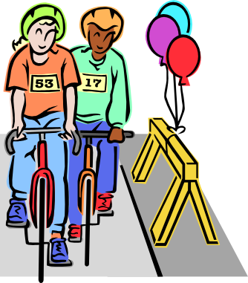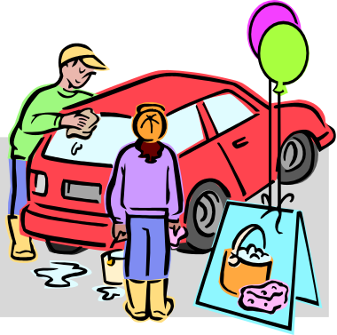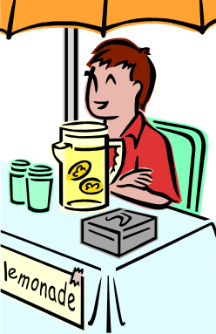
3. SERVICE TO YOUR COMMUNITY
Projects that give students an opportunity to take positive action to address needs within their local community. (See Appendix D, pgs.18-19 for nursing homes, community organizations and agencies who have requested Red Cross assistance in meeting specific community needs. Contact the agency directly for more information.)

SUGGESTED ACTIVITIES
- Collect canned foods for Operation Holiday. Note: The principal must call the School Service center to arrange for a pick-up.

- Collect aluminum cans to cash in for fundraisers. Present a “Recycle Rustler” award to students who collect the most.

- Sponsor a “White Tornado” and clean up a local shopping center, nearby park, or vacant lot in your area.

- Adopt a needy family during the holiday season.

- Learn more about the homeless population and what you can do to help. Hints for working with shelters:
Call mid-morning; they’re less likely to be busy
Bake cookies – you can deliver a batch on a regular basis
Volunteer to serve food at the shelter
Organize food, blanket, coat and/or clothing drives
Too young? Get parents involved

- Obtain an oral history from an elderly individual about his/her life and share this information with your club or class.

- Invite an elderly person to your meeting for a special “Remember When” program. They could bring pictures or items from their past to share.

- Sponsor a bingo night at a nursing home; make or donate the prizes.

- Rent a video and have a movie party for the elderly, handicapped or disadvantaged.

- Perform a “Show and Tell” for the elderly persons and ask them to return the favor.

- Make “All About Me” booklets for residents of a nursing home; include interesting facts about yourself and share it with an elderly person.

- Make holiday greeting cards for the elderly and homebound. Red Cross staff will distribute the cards.

- Conduct a Serve-A-Thon with members taking pledges from others to complete hours of service.
4. SERVICE TO YOUR GROUP, SCHOOL OR STUDENTS
Projects in this category encourage students to give something back to their school and its students.

SUGGESTED ACTIVITIES
- Cheer up homebound classmates or teachers by visits and small remembrances (card or gift) through the period of confinement.

- Take homework assignments to homebound classmates (with parents and teacher permission) to help them keep up with the rest of the class.

- Make birthday cards for each student or a bulletin board display for student birthdays each month.

- Organize and present a program on Red Cross to PTA or other groups.

- Sponsor a booth at the school carnival or Fun Night or open house with proceeds going to the Red Cross group to finance service projects. Your group can borrow the Youth Services button maker and sell buttons.

- Serve as host/hostesses during parent-teacher conferences, open houses or PTA meetings. Be sure to wear your Red Cross identification.

- Make a trash monster or collage from items picked up around your school to help demonstrate the need to keep grounds clean. Sponsor a contest between classrooms for the most imaginative, unique or the ugliest trash monster design.

- Provide a voluntary babysitting service for pre-school children during PTA or other school activities. To become certified, take American Red Cross Babysitter’s Training.

- Have a “Buddy Club” for new students in your school. Volunteers can help orient new students by giving tours of the building and by being a “special friend.”

- Tutor students with special needs; read to younger students.

- Help in your school’s library.

- Promote seat belt use. Ask students to pledge to buckle up and encourage others to do the same. Run contests on number of pledges made in each classroom.

- Sponsor a poster contest on seat belt safety.

- Honor school custodians, faculty members and staff, as well as school volunteers-especially when they are ill.

- Make holiday cards for teachers.

- Make Spirit Buttons for your school. This can be used as a fundraiser. Contact Youth Services to schedule the button maker and supplies.

- Hold A Book Drive - collect books and then distribute them to shelters, day-care centers, thrift shops or after-school programs.

- Read Aloud or into a tape recorder for a person who is visually impaired.

- Organize A Reading Hour for children at your school or library. Recruit friends to volunteer as readers.

- Make Flash Cards - Make simple reading and math flash cards for a preschool or day care center.

- Teach English, Spanish, or another language you know to a person who needs help learning.

- Tutor other people in any skill or talent you have from reading to dancing, playing an instrument or playing a sport.

- Hold a used book sale. Donate the money to a literacy group.

5. PREVENTION PROJECTS
These projects will raise awareness of community issues and to teach youth how to educate themselves and others about the value of preventive measures in problem solving. See Appendix I, pgs. 24-25 for a listing of community agencies who serve as a resource in the areas of prevention.

SUGGESTED ACTIVITIES
- Conduct a Red Ribbon Campaign and promote drug abuse prevention activities.

- Write Public Service Announcements (PSAs) with alcohol/safety message to be used over the school PA system for the holidays or at graduation/prom time.

- Make HIV/AIDS or gang violence awareness posters and post around your school.

K – 3 Classroom Activities
- Discuss peer pressure and how to make healthy choices

- Discuss healthy lifestyles

- Have students draw pictures and/or posters with drug-free messages.

4 – 6 Classroom Activities
- Discuss the Red Ribbon Pledge, “NO USE OF ILLEGAL DRUGS, NO ILLEGAL USE OF LEGAL DRUGS.” Have students define and discuss the difference between drugs that are legal/illegal, helpful/harmful and how they are misused.

- Have students write essays about alcohol and other dangers; i.e., how to avoid alcohol and other drug situations, and how to resist peer pressure.

- Have students produce bulletin boards, collages, posters and banners.

Middle/Senior High School Activities:
- Discuss the role that exercise and good health play in developing healthy minds and bodies.

- Discuss alcohol and other drug use by professional athletes and identify sports figures that are positive role models for drug abstinence.

- Create drug-free art, logos, bumper stickers, banners, collages, door decorations, bulletin boards, and school marquees.

- Have students draw a mural of activities depicting fun and healthy alternatives to using drugs.

Subject Specific Activities:
Drama – Have students write scripts and act out scenes showing kids in different situations saying “no” to drugs. Videotape the scenes and present at a school drug awareness assembly.
English – Have students read biographies about famous people who died from drugs or alcohol abuse. Ask them to write a report on how the drug-use affected their professional lives. They should discuss the potential the person failed to fulfill due to their drug use.

Foreign Language – Have students make drug-free posters in a foreign language(s).

History/Government – Highlight/discuss news articles about the government’s handling of drug smuggling, zero tolerance, supply vs. demand.

Health/Physical Education – Discuss the dangers of steroid use. Discuss your school policy on drug use and possession. Invite speakers that are in drug recovery programs to address the class.

Journalism – Produce a special edition of the school newspaper with articles about recreational alternatives to drugs and the effects of drugs on the body. Conduct a feature story contest through journalism classes eliciting the best story on alcohol, violence prevention, AIDS, personal safety etc.

Math – Project costs incurred by a “heavy smoker” over a 35-year period.

Music – Have students incorporate facts about drugs into songs.

Science – Discuss how drugs affect production and formation of proteins and DNA.



Red Cross Youth, working together to make a difference!

6. SERVICE TO THE WORLD

These projects focus on ways that students can help those in other countries and work to make our world a better place. The idea for this area of service is for students to reach beyond their own school/community.

SUGGESTED ACTIVITIES
- Measles Initiative – Every minute about one child in Africa dies from measles even though it costs less than a dollar to vaccinate a child against measles. Your club can raise money to help save these children’s lives. The American Red Cross along with the UN Foundation, Centers for Disease Control, UNICEF and World Health Organization (WHO) have joined forces to campaign for measles vaccinations for children in Africa. Contact the Health, Safety & Youth office for brochures, video or for information on how your club can get involved.

- Schedule a Red Cross representative to speak to your club about the work of the Red Cross internationally and the services provided here at home to individuals and families from other countries.

- Sponsor an International Day at your school.

- Hold a World Red Cross Day event on May 8.

- Get involved with The School Chest Program by assembling basic school and recreational supplies for children who live in disaster or other emergency areas throughout the world. (App J., pg. 26)

- Establish a pen pal with Red Cross/Red Crescent youth volunteers in other countries to share ideas.

- Make Friendship Boxes - TEMPORARY MORATORIUM ON FRIENDSHIP BOXES. As a result of the generous efforts of our community as well as others, a sufficient number of Friendship Boxes are now in stock at National American Red Cross. They ask that no Friendship Boxes be sent until further notification.

- Request a speaker to talk about the environment, their program and their commitment to education as an effective means to solve world hunger. Through Trees for Life, you can order pendants, bumper stickers, buttons, coloring cards and tree-shirts. A unique fund raising project is also available. Your group can help a school in India and at the same time earn funds for your own school. To find out more information, contact Treva Mathur at 945-6929.

- Send Holiday Cards to servicemen and women overseas through Operation Dear Abby, Wichita Eagle Mail Call or contact Disaster Services at 265-6601.

APPENDIX A SPONSOR INFORMATION FORM

This form may be completed on the computer by requesting a copy from YSWichita@usa.redcross.org.

SCHOOL/GROUP |  | ADDRESS
PHONE #  E-Mail |  | ZIP  CODE |  | SCHOOL  YEAR
SPONSOR  NAME | ETHNIC  BACK-GROUND | HOME  ZIP CODE | BIRTH  DATE | # YEARS AS A SPONSOR | E-MAIL ADDRESS

NOTE: INFORMATION REQUESTED IN SHADED AREAS WILL BE USED FOR STATISTICAL REPORTING PURPOSES ONLY.

Does your School or Organization have a Newsletter? ______________________

Would the American Red Cross be allowed to include articles
about Club activities, classes offered for youth & adults, etc.? _______________

If so, how often is the newsletter printed? _______________________________

Who receives the Newsletter? _________________________________________

When is the deadline to submit articles? _________________________________

APPENDIX B CLUB MEMBERS FORM

This form may be completed on the computer by requesting a copy from YSWichita@usa.redcross.org.
SCHOOL/GROUP NAME

DAY AND TIME  OF CLUB MEETING | YEAR
NUMBER OF YOUTH  IN ENTIRE SCHOOL/GROUP | NUMBER OF STUDENTS  IN CLUB
CLUB MEMBER NAME | HOME ZIP CODE | ETHNIC  BACKGROUND

NOTE: INFORMATION REQUESTED IN SHADED AREAS WILL BE USED FOR STATISTICAL REPORTING PURPOSES ONLY.
APPENDIX C PROJECT ACTIVITY REPORT FORM

This form may be completed on the computer by requesting a copy from YSWichita@usa.redcross.org.

It is important that we receive the form as the projects are completed. Fill in all the information requested. Please provide an explanation for any names given to groups or students such as All Stars, Super Stars, Lift Team, Sunrise Team, etc .The information included on this form helps the Youth Services Office document club activity, provide recognition and help with our statistical reporting. Report only one project per page

SCHOOL /GROUP NAME | SPONSOR NAME
# OF PARTICIPANTS  FOR THIS PROJECT | YEAR
CIRCLE ONE
GROUP OR
PREPAREDNESS COMMUNITY RED CROSS SCHOOL & STUDENTS PREVENTION WORLD
OTHER:
SUMMARY OF ACTIVITY:

COMMENTS:

APPENDIX D Resources for SERVICE TO THE COMMUNITY Projects

The agencies on the following pages have requested Red Cross assistance in meeting specific needs. If your group is interested in meeting any of the needs listed, please contact that agency for further information.

THE ARC OF SEDGWICK COUNTY – Assoc. for Retarded Citizens

Contact: Nancy Templin, 943-1191
2919 W Second Street, Wichita, Kansas 67203
Volunteers needed year round (ages 14 and older). Need table favors for Mini Tour Dinner in December; prizes for Halloween Carnival; cookies and diabetic snack foods.

CAMEO CARE CENTER
2840 S Hillside, Wichita, Kansas 67216
A nursing home with 68 residents. Youth can make weekly visits (the best visitation times are 9:00 a.m. – 12:00 p.m. and 2:00 p.m. – 4:00 p.m.); provide entertainment; craft ideas are welcomed; and adopt a grandparent.

CATHOLIC CARE CENTER Contact: Sandi Timmons-Vix, 744-4198
6700 E 45TH N, Wichita, Kansas 67226
A nursing home with 180 residents. Youth can escort residents to church or activities; one to one visits; assist with activities; serve coffee or meals; pass mail; provide afternoon entertainment, etc. Please call for more information.

GOOD NEIGHBOR NUTRITION PROGRAM, AMERICAN RED CROSS

Contact: Jessie Junious, 219-4022
Box 3726, Wichita, Kansas 67201
A federally funded program that provides the noon meal for people 60 and older. There are 30 sites in our area. Youth can provide volunteer assistance at the neighborhood sites; make holiday cards, favors or centerpieces; visit and play games (10:00 – 11:15 a.m.); put on individual or group performances (10:30 – 11:15 a.m.); help package home delivered meals (10:15 – 10:45); help serve lunch to seniors (11:30 a.m. – 12:00).

HOMESTEAD HEALTH CENTER Contact: Steve Bendsen, 262-4473
2133 S Elizabeth, Wichita, Kansas 67213
A nursing home with 80 residents. Youth can make tray favors or door decorations; 25 table decorations; visits; performances; middle & senior high students can adopt grandparents; read; do crafts; play dominoes; donations for Bingo prizes.

KANSAS MASONIC HOME Contact: Linda Smith, 267-0271
401 S Seneca, Wichita, Kansas 67213
A nursing home with 120 health care residents, 70 assisted living, and 70 independent residents. Youth can visit; make table/door decorations. Students 12 or older may assist with games and outings, Thursday morning ceramic classes; bingo on Friday afternoons; provide entertainment programs; music programs; donate items for bingo prizes.

LAKEPOINT NURSING & REHAB Contact: Gaylynn Thornburg, 943-1294
1315 N West Street, Wichita, Kansas 67203
An assisted living center with 60 residents. Youth can make door decorations; wall hangings for the holidays; provide entertainment at times other than Christmas; write letters to residents; draw colorful pictures for them.

LAKEWOOD HEIGHTS HEALTH CARE CENTER Contact: Lacie Lanning, 722-6916
1319 Seville, Wichita, Kansas 67209
A nursing home with 100 residents. Youth can make name tags for doors with holiday themes; donate bingo prizes (including stuffed animals and costume jewelry); provide entertainment anytime; reading; writing letters; visiting.

LINCOLN EAST Contact: Toji, 683-7588
4007 E Lincoln, Wichita, Kansas 67218

Youth can provide decorations, visits, caroling or adopt one of the 60 senior residents.

MAKE-A-WISH FOUNDATION OF KANSAS Contact: Pat Greenway, 838-9474
P.O. Box 3116, Wichita, Kansas 67201-3116
A wish granting agency for children ages 2 ½ to 18 who have life threatening illnesses or medical conditions. Youth can conduct in-school fund raising campaigns (organization can supply containers and brochures). Speakers are available.

RONALD MCDONALD HOUSE Contact: Kelly Cain-Swart, 269-0620
1110 N Emporia, Wichita, Kansas 67214 Web site: www.ronaldhousewichita.org
Ronald McDonald Houses are homes where family members of ill children stay while the children are being treated in Wichita Hospitals. Service project ideas: bake cookies, donate groceries and supplies, yard clean up and meal preparation (average 10 people). Speakers and a video are available. Call to arrange for speaker, video or house tour.

WESTVIEW OF DERBY Contact: Beth Murie, 788-3739
445 N Westview, Derby, Kansas 67037
A nursing home with 120 residents. Youth can adopt-a-grandparent; play games; provide entertainment; assist with bingo and other activities; read to residents and many other opportunities.

WICHITA PRESBYTERIAN MANOR Contact: Amy Meyers, 942-7456
4700 W 13TH Street, Wichita, Kansas 67212
Youth can provide music programs; visits; take residents out for walks; read to residents; make table decorations/tray favors (60); Adopt a Grandparent program.
APPENDIX E Resources for SERVICE THROUGH THE RED CROSS Projects

HOLIDAY STOCKING PROJECT
We no longer have stockings for clubs to fill, but here’s another option for your club. Maize Elementary collected enough items to fill 47 extra large gift bags! They delivered to two nursing homes and their residents and staff were thrilled. This idea actually worked better than filling the stockings and your club could do this any time of the year!

PROJECT OVERVIEW
This project is a rewarding class or youth group activity designed to teach youth the importance of giving to the community, as well as to help brighten the holidays for area nursing homes, children's homes and homeless shelters.

Club members are asked to collect small gifts and place in large gift bags, and then deliver to their chosen group. Please do not send used items. Personalize by having members write letters or make cards for the recipients.

Suggested items
Nursing home, children's home or shelter staff will also have suggestions for their residents:

- Socks or slippers with grips

- Cologne
- Books
- Lotions
- Snacks (non-perishable, individually wrapped)
- A book of poems written by students
- "All About Me Books" (see page 9)
- Ornaments/decorations
- Craft items made by students
- Toys/Stuffed Animals

APPENDIX F Resources for SERVICE THROUGH THE RED CROSS Projects

VOLUNTEER RECRUITMENT CAMPAIGN FOR RED CROSS - BOOKMARKS

Grade Schools

Decorate the back of Red Cross bookmarks with drawings of what the Red Cross means to you! Students should include a red cross and draw on the BACKS ONLY of the bookmarks.

Bookmarks will be laminated and used as handouts at speaking engagements, volunteer fairs, libraries, bookstores, grocery stores, and mailings to potential volunteers.

Be Creative! A good example of a bookmark from a previous year is pictured below.

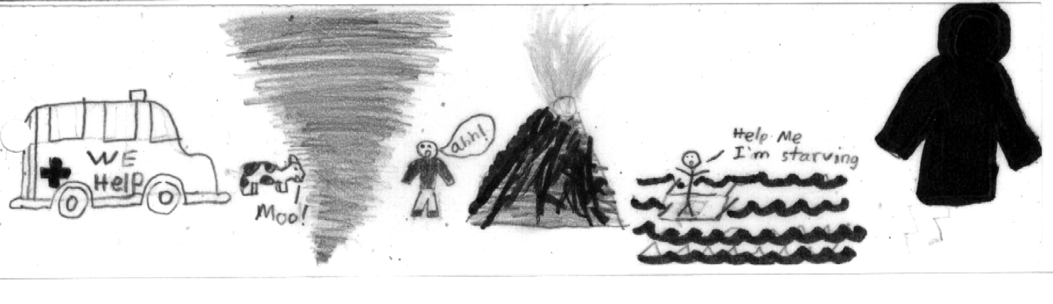

Middle/High Schools

You can create a unique Recruitment campaign! Your group picks the theme, ideas, etc. then presents their plan to the chapter in hopes that it may help to recruit more Red Cross volunteers.
Choose recruitment campaign for Transportation Services, Disaster Services, Health, Safety & Youth Services or any local Red Cross program.

If your group would like to take part in this project, call the Health, Safety & Youth Services at 219-4080 or 219-4061 and request the number of bookmarks for your club members to complete.

APPENDIX G Resources for SERVICE THROUGH THE RED CROSS Projects

FIRST AID KIT IN A CAN

Make your own or donate them to the American Red Cross for victims of disasters, transportation clients or Good Neighbor Nutrition customers! This is an effective, yet inexpensive first aid kit. It can be made with a two or three pound coffee can with a plastic lid or other suitable container. (e.g. child’s lunch box, plastic ice cream pail, fanny pack) Contents can be obtained from first aid supplies found around the home or purchased at minimal cost.

These kits prove a great value when carried in the trunk of your car or boat, or while picnicking, camping or whenever you are away from home. By sealing the lid tightly with tape, the contents of the case will last indefinitely.

Suggested items include:

- General written First Aid instructions (from Red Cross Health & Safety office or medical supply stores).
- 2-inch & 3-inch sterile gauze pads
- Hypoallergenic adhesive tape
- Triangular bandages & 2-inch & 3-inch sterile roller bandages
- Scissors
- Needle
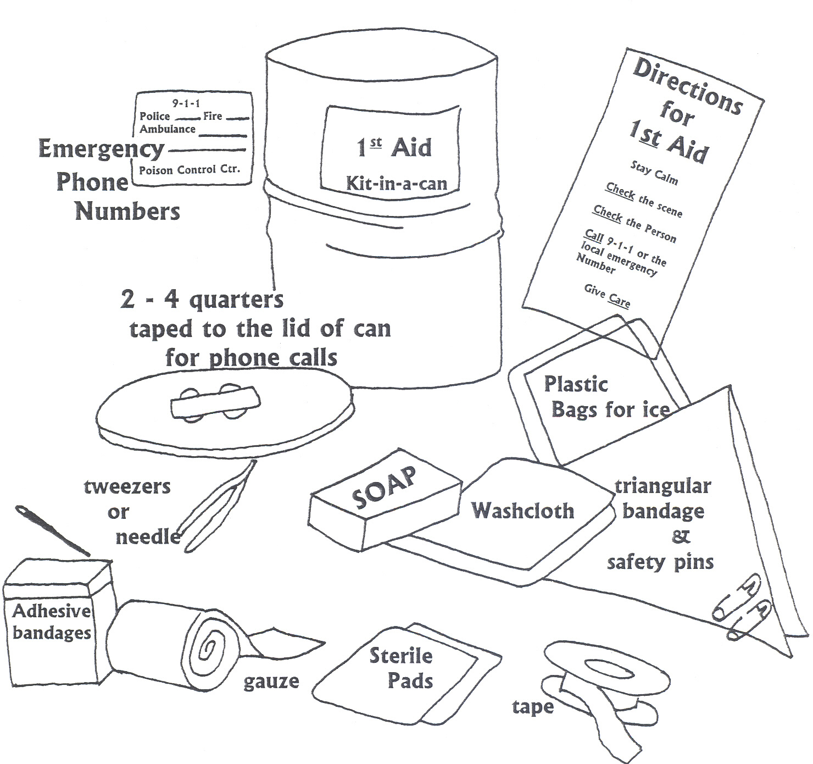
- Bar of soap
- Moistened Towelettes
- Antiseptic Spray
- Thermometer
- Tongue Blades and Wooden Applicator Sticks
- Tube of Petroleum jelly or other lubricant
- Safety pins-assorted sizes
- Latex Gloves
APPENDIX H Resources for SERVICE THROUGH THE RED CROSS Projects

AMERICAN RED CROSS
DISASTER COMFORT KITS

These are Personal Care Kits provided to disaster victims for immediate personal hygiene needs following disasters.

These kits can be pre-purchased (contact the Health, Safety & Youth office) or your club can gather and assemble items then donate them to the American Red Cross to be given to disaster victims. Sample sizes are preferred.

The American Red Cross provides bags for the personal care kit items to be assembled.

Each comfort kit is required to have:

- Deodorant

- Toothpaste
- Toothbrush
- Bar of Soap
- Washcloth
- Comb
- Skin Lotion
- Disposable razor
- Shampoo

Optional Items:
- Conditioner
- Shave Cream
- Toys/books

APPENDIX I Resources for PREVENTION Projects

The following community agencies serve as resources in the area of prevention. If your group is in need of a speaker, printed materials, or more information, please contact the agency for further information.

SUBSTANCE ABUSE & VIOLENCE PREVENTION
Police-School Liason Program & D.A.R.E.
Contact: Karen Raines, 268-4207
455 N Main, Wichita KS 67202
Speakers are available on a wide variety of topics including: substance abuse; personal safety; vandalism; runaways; drunk driving and child abuse.

The Regional Prevention Center
Contact: Sarah Bengtson, 262-2421
1421 E 2ND Street, Wichita KS 67214
The Regional Prevention Center provides educational resources such as pamphlets, videos, and books regarding alcohol, tobacco, or other drugs. Videos, brochures and handouts are available on a wide variety of topics related to alcohol and other drugs, drinking and driving, peer pressure, self-esteem and other related issues.

Wichita Public School System Substance Abuse
And Violence Prevention Intervention Office
Contact: Debbie McKenna, School Service Center, 973-2260
3850 N Hydraulic
Wichita KS 67219-3399
Speakers are available on drug education, gang and other youth violence. The office can also provide assistance, on a request basis, for school and parent-based programs.

HEALTH ISSUES
American Red Cross
Contact: Health, Safety & Youth Services, 219-4080

Box 3726, Wichita KS 67201
Speakers are available to present accurate, age-appropriate information on HIV/AIDS for elementary through high school classes. A variety of speakers are available such as health care workers, teenagers, adults and HIV positive individuals. Videos and brochures are available.

Wichita-Sedgwick County Department of Community Health

1900 E 9TH Wichita KS 67214
660-7300
The Health Department hopes achieve full immunization for all children by the age of two. Speakers on this topic are available on a limited basis. Flyers, immunization information and buttons are available for club use.
- Students can distribute information at a school health fair or PTA meeting and check with mom or dad to see if baby brothers and sisters have been immunized.

The Health Department participates in many community health events. Each April, a hand washing program is held at the Sedgwick County Zoo in conjunction with Via Christi/St. Francis Childrens’ Health Fair. At this event thousands of children are taught the proper procedures of hand washing and are educated as to the importance of good hygiene.
- Volunteers are needed to help children with the hand washing activity and to distribute free materials.

In February each year, the Children’s Dental Clinic in association with the Wichita District Dental Society presents the “Molardrama”. This play is done for over 5,000 second graders in 10 performances at the Wichita Children’s Theatre and Dance Center. The children are given dental education in an entertaining way that they remember for many years. Contact: Kerry at 660-7317
- Volunteers are needed at each performance to help greet the children, distribute teacher packets and seat the children.



Red Cross Club Members…………………………Making a Difference in our Community and the World!
APPENDIX J Resources for SERVICE TO THE WORLD Projects

The School Chest Program has been touching lives of children who live in disaster and other emergency areas in both the United States and abroad. By providing basic school and recreational supplies for a class of 40 students, the School Chest Program offers a way for young people in your community to help other children in need and to promote understanding among youth.

All school chest items should be new, clean and of good quality and appearance. It is important to gather all the items for the chest BEFORE purchasing the school chest, preventing a possible discovery that the selected container is too small.

Each chest should contain the following items:
- notebooks/notepads (lined 8 ½” x 11” composition books/bound notebooks)
- no. 2 unsharpened pencils with erasers

- small pencil sharpeners
- metric or metric-inch rulers
- small compasses
- boxes of colored chalk
- blackboard erasers
- packages of 8 ½” x 11” drawing paper
- boxes of eight crayons/colored pencils
- metric tape measure
- soccer ball
- jumpropes

School chest containers need to be approximately 35"L x 20 3/8"W x 17"H (or 30 quart capacity) and made of HDPE high density polyethylene. The container should have recessed handles, a lockable lid, and should be stackable. DO NOT SEAL THE CHESTS as they will be checked by Health, Safety & Youth Services in Wichita and the National American Red Cross warehouse. Suggest Clubs raise funds to pay for shipping
APPENDIX L Midway-Kansas Chapter Programs & Services

Serving Sedgwick, Sumner, Harper, Harvey and Kingman Counties

DISASTER SERVICES provides help 24 hours a day to individuals and families who have disaster-caused emergency needs such as food, rent, and medical supplies. Red Cross volunteers and staff respond to disasters ranging from a family-home fire to tornadoes and floods. Red Cross also trains disaster volunteers who become part of our local, state, and national preparedness and response network. Community disaster educational materials and speakers are also provided. All Red Cross disaster assistance is free.

FAMILY SUPPORT SERVICES provides a variety of emergency financial and communications services using licensed social workers and trained volunteers. Programs include:
- Armed Forces Emergency Services The American Red Cross is congressionally mandated to provide emergency communications to military personal and their families 24 hours a day.
- Civilian Financial Assistance Individuals experiencing an unexpected financial situation that leaves them unable to pay their rent/utilities are eligible to apply for financial assistance. Referring individuals to local community resources is also provided.
- International Services The American Red Cross helps families locate and contact loved ones around the world, provides relief to areas of war and disaster worldwide, and provides tracing services for victims of war and the Holocaust.
- Language Bank The Red Cross serves as a foreign language translation service during emergency situations.
- Project Deserve The American Red Cross, through a partnership with Westar provides energy-related emergency financial assistance to those over age 60 and to those who are severely disabled.
- Victims of Crime The Red Cross provides financial assistance for basic household needs to those over age 60 or those with severe disabilities who have been victims of a crime during which some or all of their income was stolen.

GOOD NEIGHBOR NUTRITION PROGRAM provides social activities and serves nearly 1,200 hot, nutritionally-balanced meals each weekday noon to residents age 60 or older in Butler, Harvey, and Sedgwick counties. This program is funded under the Older Americans Act through the Central Plains Area Agency on Aging and the Kansas Department of Aging, with Red Cross sponsorship providing support services.

HEALTH & SAFETY SERVICES provides safety outreach, information, education and training to enable people to promote, achieve and sustain healthier, safer lives, and prepare for and respond effectively to emergencies. Health and Safety training programs include: First Aid, CPR, aquatics, HIV/AIDS education, babysitting, small craft safety
SENIOR WORK EXPERIENCE PROJECT places economically disadvantaged people over age 55 in training positions at non-profit agencies in Butler, Cowley, Harper, Harvey, Kingman, Reno, Sedgwick, and Sumner counties. The Kansas Department of Human Resources and the U.S. Department of Labor fund this program with Red Cross support services.

TRANSPORTATION SERVICES provides free rides for the elderly. Volunteers drive radio-equipped Red Cross vehicles to take clients to and from Good Neighbor Senior Dining Centers, medical appointments and on occasion, to special community events.

VOLUNTEER SERVICES recruits, coordinates and recognizes volunteers who provide clerical assistance, work on disaster assignments, instruct First Aid/CPR, HIV/AIDS and water safety classes, drive the elderly to senior dining centers and medical appointments, and conduct interviews as social services caseworkers.

YOUTH SERVICES offers Red Cross Community Services Clubs as well as Count Youth INvolved, which provides opportunities for 12 - 18 year-olds to volunteer at the Red Cross in Disaster, Transportation, Health and Safety, Blood Services as well as other departments.

Thank you for sponsoring a Red Cross Club!

